Metallic Bonding

Diagram:

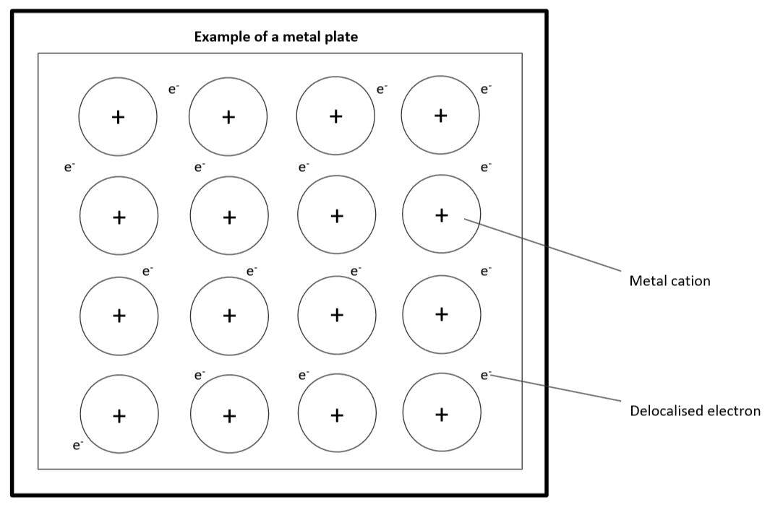

Definition: Metallic bonding is the electrostatic attraction between metal cations and a sea of delocalised electrons in a network.

Note: Metallic bonds are non-directional because the electrons are free to move between cations.

Describe and explain the following physical properties of metals:

- high melting point:
Metals have a high melting point because they have very strong electrostatic attraction between the metal cations and sea of delocalised electrons in a network which keeps the large network together under high temperatures.

- high boiling point:
Metals have a high boiling point because they have very strong electrostatic attraction between the metal cations and sea of delocalised electrons in a network which keeps the large network together under high temperatures.

- electrical conductivity:
Metals have strong electrical conductivity due to how the atoms bond together in networks. The electrons in the outermost shell of the metal become delocalised and free to move around. This allows electricity to flow easily through the metal because there are already electrons free in the network. The more delocalised electrons per metal cation in a network, the greater the electrical conductivity is.

- Malleable:
Metals are very malleable because the atoms in a metal network are held together by the very strong electrostatic attraction created between the metal cations and sea of delocalised electrons in the network. When hit by a strong force the atoms can roll over each other without having their bonds broken due to the strength of the electrostatic attraction.

- ductile:
Metals are very ductile because the atoms in a metal network are held together by the very strong electrostatic attraction created between the metal cations and sea of delocalised electrons in the network. When hit by a strong force the atoms can roll over each other without having their bonds broken due to the strength of the electrostatic attraction.

Sodium, magnesium and aluminium

Element | Na | Mg | Al
Electronic configuration | 2, 8, 1 | 2, 8, 2 | 2, 8, 3

Sodium, magnesium and aluminium are all metals. They have metallic bonding, in which positive metal ions are attracted to negatively charged electrons.
Going from sodium to aluminium:
- the charge on the metal ion increases from +1 to +3 (with magnesium at +2),

- the number of delocalised electrons increases,

- so

the strength of the metallic bonding increases,
- the melting points and boiling points increase.

For each of the following purposes, suggest an important metallic property that makes it suitable for that purpose.

- Copper is used in electrical wiring
- Very strong conductor of electricity

- Iron is used in construction of bridges
- Iron is very strong

- Aluminium is used to make saucepans
- Good thermal conductor
- High melting point

- Jewellery is commonly silver and gold
- Appearance and rarity
  - Silver and gold are shiny

- Electric light filaments are made of tungsten
- Conducts electricity

Use the information in the table to answer the following questions
Element | Melting point (⁰C) | Electrical conductivity (MS m⁻¹)
Sodium | 98 | 21
Magnesium | 650 | 22
Aluminium | 670 | 37

Is there any pattern in the data?
Increasing the number of outermost electrons increases the melting point and electrical conductivity of metal elements.

Explain any patterns identified previous question in terms of delocalised electrons.
Due to the number of delocalised electrons being dependent on the number of electrons in a metal element’s outermost energy shell, an increase in melting point and electrical conductivity is also linked to the number of delocalised electrons as a connection between the number of electrons in the outermost shell was linked to these properties above.

